The Earth

We live on the planet Earth.
Which picture best shows what the Earth is like?

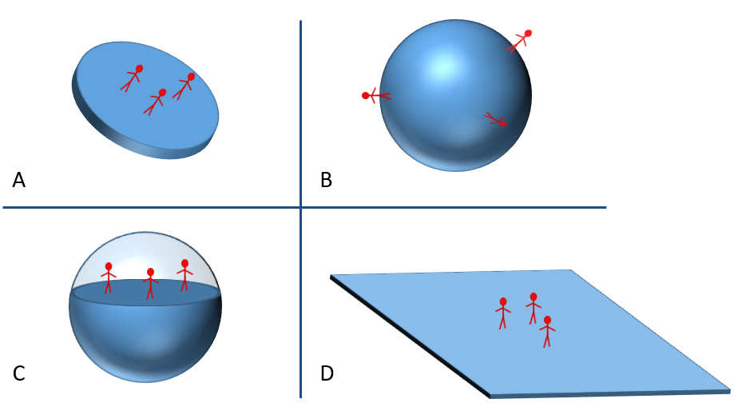

Physics > Big idea PES: Earth in space > Topic PES1: Solar System and beyond > Key concept PES1.1: Planets and the Solar System
Diagnostic question
The Earth

Overview
Learning focus: | In the Solar System: eight planets orbit a star called the Sun; moons orbit most of the planets; and the planets spin on their axes. We live on the Earth where: a year is defined as the time for the Earth to orbit the Sun; a day as the time it takes the Earth to spin on its axis; and the Moon orbits in about 28 days. The planets are very small compared to the huge distances between them.
Observable learning outcome: | - Identify that we live on the surface of the Earth which is a sphere
Question type: | Diagnostic, simple multiple choice
Key words: | Earth, planet

P | PRIOR UNDERSTANDING  This diagnostic question probes understanding of ideas that are usually taught at age 5-11, to aid transition from earlier stages of learning.

What does the research say?
Research has shown that the majority of young children aged 8-10 have a naïve understanding of the Earth as being flat. By age 12 most understand the Earth to be spherical, although for many correct ideas about gravity tend to develop later (Nussbaum, 1985; Driver et al., 1994; Baxter, 1989).
Over four studies it was found that a flat Earth model (A or D) is held by about a sixth of 11-12 year-olds, the hollow Earth model (C) by another sixth, and two-thirds understand that the Earth is a solid sphere. By age 13-14 the latter number increases to about 95% (Nussbaum, 1985).
Ways to use this question
Students should complete the question individually. This could be a pencil and paper exercise, or you could use an electronic ‘voting system’ or mini white boards and the PowerPoint presentation.
The answers to the question will show you whether students understood the concept sufficiently well to apply it correctly.
If there is a range of answers, you may choose to respond through structured class discussion. Ask one student to explain why they gave the answer they did; ask another student to explain why they agree with them; ask another to explain why they disagree, and so on. This sort of discussion gives students the opportunity to explore their thinking and for you to really understand their learning needs.

Differentiation
You may choose to read the questions to the class, so that everyone can focus on the science. In some situations it may be more appropriate for a teaching assistant to read for one or two students.
Expected answers
B – the Earth is a solid sphere
How to respond - what next?
About half of students aged 8-9 imagine the Earth to be flat (A or D) and another 40% combine a flat Earth model with the idea that the Earth is a sphere by adopting model C.
Option A is an alternative way of linking a flat Earth view with two-dimensional drawings of the Earth in books. To an individual stood on the Earth the surrounding land does look ‘flat’ so these views are reasonable. The change to a scientific understanding is helped by instruction, but also appears to be partly limited by age and experience.
If students have misunderstandings about the shape of the Earth, they may not have made a connection between a globe and where we live. Asking them to find different countries and places they know on a globe map can help them make this connection. Video images that show the Earth as three-dimensional can also reinforce the scientific view (Allen, 2014).
The following BEST ‘response activity’ could be used in follow-up to this diagnostic question:
- Response activity: Modelling the Earth
Acknowledgments
Developed by Peter Fairhurst (UYSEG), based on illustrations in Making Sense of Secondary Science (Driver et al., 1994).
Images: Peter Fairhurst (UYSEG)
References
Allen, M. (2014). Misconceptions in Primary Science, Second edn Berkshire, UK: Open University Press.
Baxter, J. (1989). Children's understanding of familiar astronomical events. International Journal of Science Education, 11 (Special Issue), 502-13.
Driver, R., et al. (1994). Making Sense of Secondary Science: Research into Children's Ideas, London, UK: Routledge.
Nussbaum, J. (1985). The Earth as a cosmic body. In Driver, R., Guesne, E. & Tiberghien, A. (eds.) Children's Ideas In Science. Milton Keynes: Open University Press.

